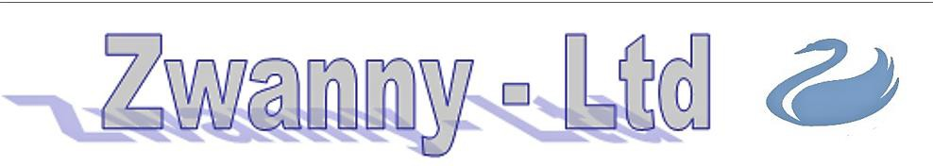

Minimax 12 Skimmer 226005
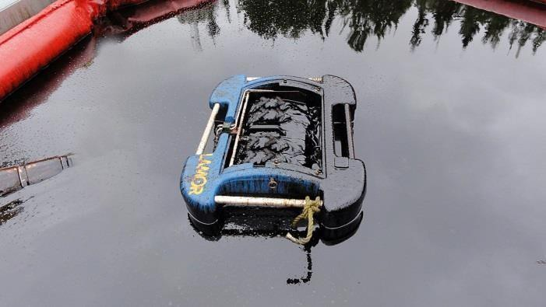
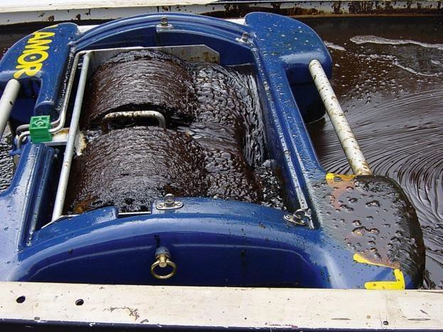
The Minimax 12 is a light, portable oleophilic brush skimmer, designed to recover oil from shorelines, harbors, rivers and lakes. The skimmer has proven its efficiency in continuous recovery operations in hundreds of oil spills worldwide, in all climatic conditions and varying types of spilled oils.

The Minimax 12 utilizes the well proven Lamor brush wheel system, which combines high oil recovery capacity with a low free water pick-up rate of less than 5 %. The brush wheels recover any floating oils which remain fluid.

The weight of the hand portable Minimax 12 is only 28 kg (62 lbs). The body of the skimmer is made of fiberglass. The skimmer is entirely hydraulic operated and its power requirement is low. The unit is designed to be connected to a suction pump or vacuum system.

.The maximum capacity in ideal conditions is 19.6 m³/h and is certified by Bureau Veritas.

Technical Specifications: Benefits:
Length
835 mm
33 in
Width
665 mm
26 in
Height
357 mm
14 in
Draft
120 mm
5 in
- Portable and light-weight
- Easily deployed
- Recovery of light to heavy viscous oils
- Low free-water content, <5 %
- Recovery capacity certified by Bureau Veritas
- User friendly
Weight
28 kg
62 lbs
Certified capacity
19.6 m³/h*
85 gpm*
Free water collected
Hydraulic flow (skimmer)
Hydraulic pressure
<5 %
<5 %
1-3 l/min
0.3-0.8 gpm
60-100 bar
870-1450 psi
*Capacity related to pump selection
Power
0.5 kW
0.7 hp

www.zwannyltd.com

